Here’s how it works…  - We will be showing eight films of actual horse races throughout the evening, each with eight numbered horses.  - Place a bet at the tote table on whichever horse you think will win the race.  - You can bet on as many horses as you like, as many times as you like.  - You will be given a ticket for each bet. Hold on to this, you’ll need it to claim your winnings.  - When all bets have been placed, the race will be shown and the winner displayed.  - If your horse is the winner, collect your winnings from the tote table.    www.racenight.co.uk |  | 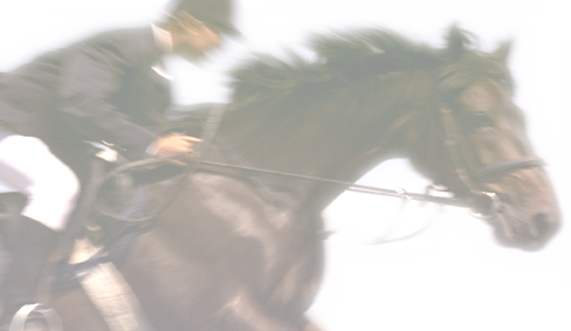
  WELCOME TO THE
  RACENIGHT UK CHARITY
  Race Evening 2017
  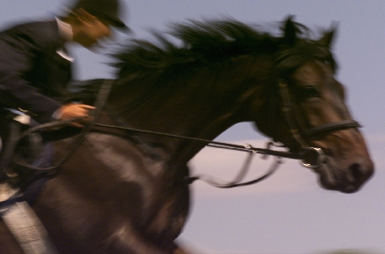
  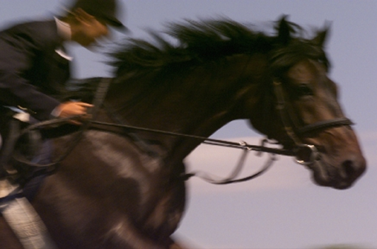
  Monday 1st January 2017
  At the Racenight UK Office

Race 1 SPONSORED BY RACENIGHT UK  - NEVER ON TIME Type the names  - IRISH MIST Of your horse  - CHOPPER Owners here  - SHOWTIME Sarah Jones  - BIRTHDAY BOY John Smith  - STRATHCLYDE Sarah Jones  - WHATS HIS NAME John Smith  - CENTRE POINT Sarah Jones  Race 2 SPONSORED BY RACENIGHT UK  - ROCKET Sarah Jones  - MEXICAN GUNSLINGER John Smith  - SCORPION STING Sarah Jones  - STORMY NIGHT John Smith  - GREENKEEPER Sarah Jones  - PURPLE HEATHER John Smith  - VALENTINE Sarah Jones  - ODDBALL John Smith  Race 3 SPONSORED BY RACENIGHT UK  - MATRONS PET Sarah Jones  - WELSH WITCH John Smith  - MAD MAX Sarah Jones  - JOCKS JUMPER John Smith  - NEDS DONKEY Sarah Jones  - TRICKY DICKY John Smith  - KICKER Sarah Jones  - TAKE THAT John Smith  Race 4 SPONSORED BY RACENIGHT UK  - BONANZA Sarah Jones  - CELTIC FLYER John Smith  - MY HERO Sarah Jones  - HOSPITAL CASE John Smith  - MASTER CHARLES Sarah Jones  - BETTER LATE THAN NEVER John Smith  - CAMBERWELL BEAUTY Sarah Jones  - BRASS BAND John Smith |  | Race 5 SPONSORED BY RACENIGHT UK  - GOLD BAR Sarah Jones  - LINGUIST John Smith  - CHAMPION Sarah Jones  - EARLY RISER John Smith  - LOCK IN Sarah Jones  - BASHFUL John Smith  - DOMINO Sarah Jones  - JUST THE TICKET John Smith  Race 6 SPONSORED BY RACENIGHT UK  - PIT PONY Sarah Jones  - MAD AXEMAN John Smith  - SHY BOY Sarah Jones  - FINAL DEMAND John Smith  - GLORIA Sarah Jones  - DONNA John Smith  - THOUGHT FOR THE DAY Sarah Jones  - PINK ELEPHANT John Smith  Race 7 SPONSORED BY RACENIGHT UK  - TEACHERS TROUBLE Sarah Jones  - SOLACE John Smith  - NEARLY MADE IT Sarah Jones  - TIME OUT John Smith  - GAMEBOY Sarah Jones  - RAREBIT John Smith  - FATAL ATTRACTION Sarah Jones  - GO FOR BROKE John Smith  Race 8 SPONSORED BY RACENIGHT UK  IN THIS RACE ALL HORSES ARE FOR SALE TO THE HIGHEST BIDDER.

